**Tester Document for Space Traffic Density Analysis**

**Version:** 1.0  
**Date:** 27th November 2024  
**Prepared By:** Shravani R S

**TEAM MEMBERS**

1. SHRAVANI R S

2. Himaja S

3. Karanbir Singh

4. Tarunaa A C

5. Anushka Dutta

**Table of Contents**

1. Project Overview
2. Test Plan
3. Test Cases
4. Defect Reporting
5. Test Summary
6. Sign-Off
7. **Project Overview**

**Project Name:** Space Traffic Density Analysis  
**Objective:** To analyze space traffic density, identify trends, and build a predictive model using linear regression.  
**Scope:**

* Included: Data cleaning, analysis, feature engineering, and regression modeling.
* Excluded: Deployment in production.

**Key Components of Testing**:

* Data Analysis Modules: Null values, outlier detection, univariate and bivariate analysis.
* Feature Engineering Techniques: Encoding, standardization, and column transformation.
* Predictive Model: Validation of the linear regression model's robustness.

1. **Test Plan**

**Testing Types:**

1. **Functional Testing:** Validate the correct execution of each module.
2. **Data Validation Testing:** Ensure data accuracy and integrity post-cleaning.
3. **Regression Testing**: Ensure no errors introduced during feature engineering.
4. **Model Validation Testing:** Assess model accuracy and robustness.

**Testing Tools:** Python (pandas, matplotlib, seaborn, sklearn).

**Test Environment:**

* Platform: Python 3.9, Jupyter Notebook.
* Libraries Used: pandas, numpy, matplotlib, seaborn, sklearn.
* System Configuration: Windows 10, 16GB RAM.

**3. Test Cases**

**3.1. Data Import and Understanding**

***Test Case 1: Import Dataset***

* **Test Case ID**: TC001
* **Objective**: Validate successful import of the Space Traffic Density dataset.
* **Preconditions**: Dataset file should exist in the specified location.
* **Steps**:
  1. Write the pandas.read_csv() command.
  2. Check for errors during import.
* **Expected Result**: Dataset imported successfully, with no errors.
* **Status**: Pass/Fail

***Test Case 2: Dataset Overview***

* **Test Case ID**: TC002
* **Objective**: Ensure df.head(), df.info(), and df.describe() provide correct information.
* **Steps**:
  1. Print the first five rows of the dataset using df.head().
  2. Verify the dataset structure with df.info().
  3. Use df.describe() to check summary statistics.
* **Expected Result**: Dataset displays correct shape, data types, and statistics.
* **Status**: Pass/Fail

**Data.head()**

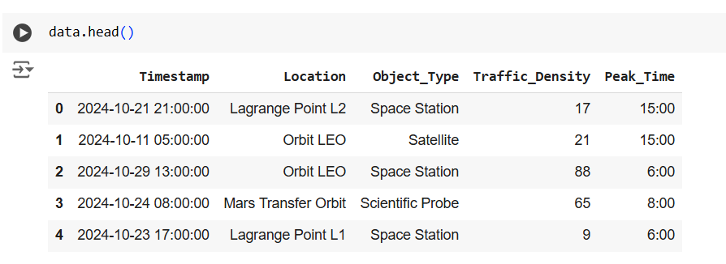

**Data.describe()**

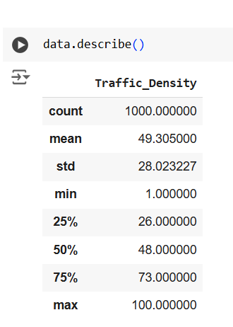

**Data.info()**

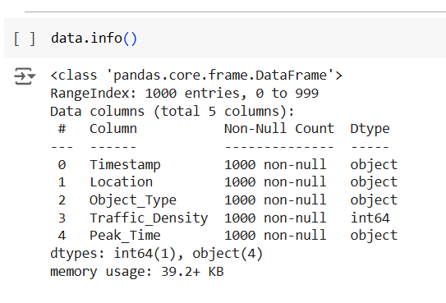

**3.2. Data Cleaning**

***Test Case 3: Handle Null Values***

* **Test Case ID**: TC003
* **Objective**: Identify and impute/remove null values in the dataset.
* **Steps**:
  1. Use df.isnull().sum() to find null values.
  2. Impute/remove nulls as per the strategy.
* **Expected Result**: No null values remain after execution.
* **Status**: Pass/Fail

**Data.insull().sum()**

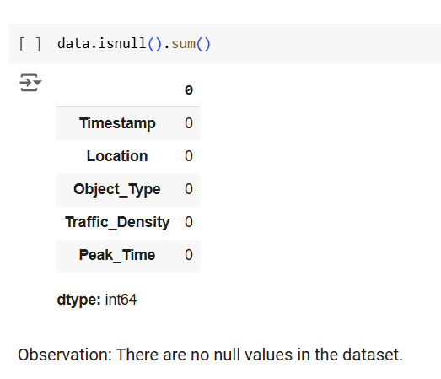

***Test Case 4: Handle Outliers:***

* **Test Case ID**: TC004
* **Objective**: Detect and handle outliers in numerical variables (Traffic_Density).
* **Steps**:
  1. Plot boxplots for numerical variables.
  2. Apply IQR method or capping for outliers.
* **Expected Result**: Outliers are handled appropriately.
* **Status**: Pass/Fail

**OUTLIERS**

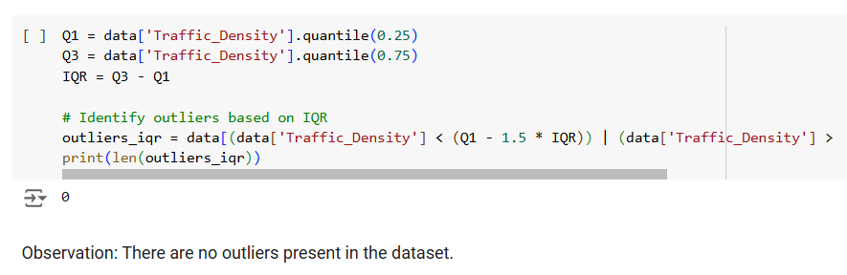

**BOX PLOT**

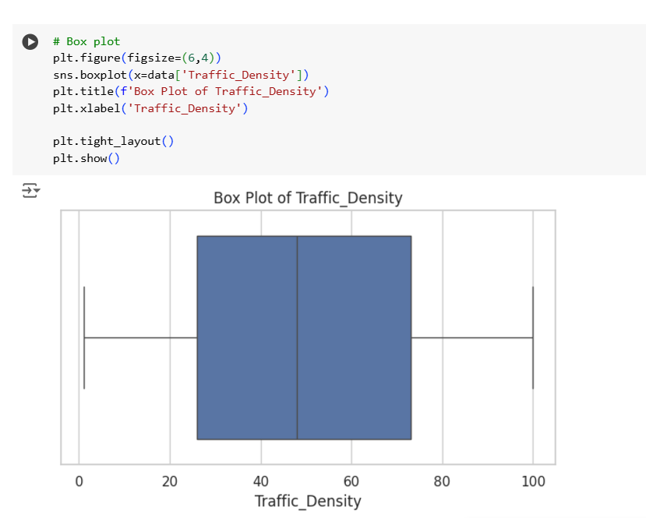

**3.3. Univariate Analysis:**

***Test Case 5: Numerical Variable Analysis***

* **Test Case ID**: TC005
* **Objective**: Validate the distribution plot of Traffic_Density.
* **Steps**:
  1. Plot a histogram or KDE plot.
  2. Check for normality.
* **Expected Result**: Correct distribution displayed.
* **Status**: Pass/Fail

**HISTOGRAM**

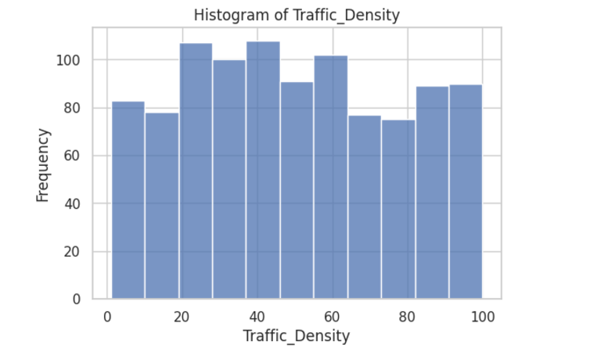

**3.4. Feature Engineering**

***Test Case 6: One-Hot Encoding***

* **Test Case ID**: TC006
* **Objective**: Validate correct creation of dummy variables.
* **Steps**:
  1. Apply one-hot encoding to Object_Type and Location.
  2. Verify new columns are created correctly.
* **Expected Result**: Dummy variables are generated without errors.
* **Status**: Pass/Fail

***Test Case 7: Handle Dummy Variable Trap***

* **Test Case ID**: TC007
* **Objective**: Validate removal of one dummy variable to prevent multicollinearity.
* **Steps**:
  1. Remove one column from each set of dummy variables.
  2. Check for issues in regression modeling.
* **Expected Result**: No multicollinearity issues.
* **Status**: Pass/Fail

**3.5. Linear Regression Model:**

Test Case 8: Train and Validate Linear Regression

Test Case ID: TC008

Objective: Verify model performance metrics (R², MAE, RMSE).

Steps:

Train the model using LinearRegression().

Validate model accuracy using metrics.

Expected Result: Model achieves acceptable performance (e.g., R² > 0.8).

Status: Pass/Fail

**LINEAR REGRESSION MODEL**

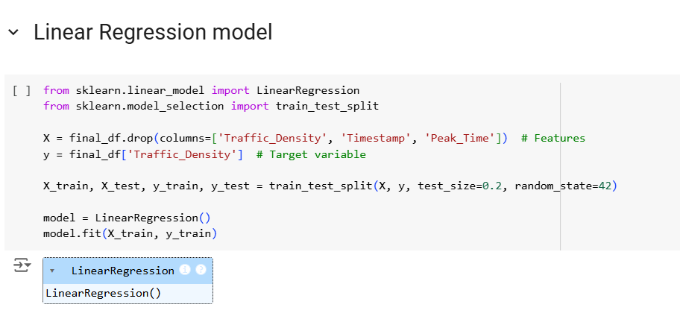

**RESIDUAL ANALYSIS**

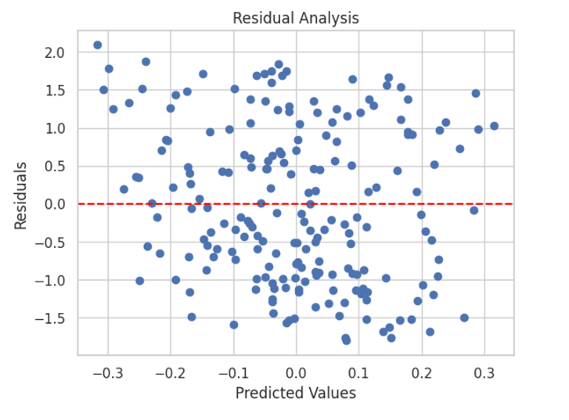

**4.Test Execution Log:**

|  |  |  |  |  |
| --- | --- | --- | --- | --- |
| **TEST CASE ID** | **TEST CASE TITLE** | **EXECUTION STATUSE** | **TIME TAKEN** | **REMARKS** |
| TC001 | Import Dataset | pass | 1 min | Dataset imported successfully |
| TC002 | Dataset Overview | Pass | 2 min | Structure and stats verified |
| TC003 | Handle Null Values | Pass | 3 min | Null values imputed |
| TC004 | Handle Outliers | Pass | 2 min | Outliers capped |
| TC005 | Univariate Analysis: Traffic_Density | Pass | 2 min | Histogram show correct distribution |
| TC006 | One-Hot Encoding | Pass | 3 min | Dummy variable created |
| TC007 | Handle Dummy Variable | Pass | 2 min | Redundant variables removed |
| TC008 | Train and Validate Linear Regression | Pass | 10 min | Model trained and validated successfully |

**5.Extended Defect Reporting:**

The **Defect Reporting** section provides a structured approach to track and resolve issues identified during testing.

|  |  |  |  |  |
| --- | --- | --- | --- | --- |
| **DEFECT ID** | **DESCRIPTION** | **SEVERITY** | **STEPS TO REPRODUCE** | **STATUS** |
| DEF001 | Incorrect one-hot encoding implementation | Medium | Verify encoded columns for categorical variables | Closed |
| DEF002 | Linear Regression accuracy is low | Critical | Train linear regression, check R2  score | In progress |
| DEF003 | Skewness in traffic_density variable | Medium | Plot histogram, observe distribution | Closed |

1. **Test Summary**

**Test Metrics:**

* Total Test Cases: 8
* Test Cases Passed: 8
* Test Cases Failed: 0

1. **Sign-Off**

|  |  |  |
| --- | --- | --- |
| **ROLE** | **NAME** | **DATE** |
| TESTER | SHRAVANI R S | 27-NOV-2024 |